STRUCTURAL ASPECTS OF COPPER(II) 2,6-PYRIDINEDICARBOXYLATES

D. Mikloš (a), P. Segľa (a), J. Jašková (a), M. Koman (a), T. Glowiak† (b), T. Lis (b) and M. Melník (a)

(a) Faculty of Chemical and Food Technology, Slovak Technical University,
Radlinského 9, 812 37 Bratislava, Slovak Republic
(b) Faculty of Chemistry, Wroclaw University, F. Joliot-Curie 14, 50383 Wroclaw, Poland

Pyridinecarboxylate ligands can exhibit various modes of coordination to a central atom especially because of a variety of coordination possibilities of carboxyl groups and an additional possibility to coordinate also through the nitrogen atom of pyridine. Synthesis, spectral and magnetic properties, antimicrobial effects and crystal structures of various complexes CuX₂⋅nH₂O (where X is nicotinate (nic), isonicotinate (isonic), 2,6-dimethoxynicotinate (2,6-(MeO)₂nic) or 2-methylthionicotinate (2-MeSnic); n = 0−4) as well as of their molecular adducts with chelating ligands ethylenediamine (en), bipyridine (bipy) or diethylenetriamine (dien) have been reported in our previous papers[1–3].
2,6-pyridinedicarboxylic acid (2,6-pydcaH₂) and its deprotonated forms are known to exhibit especially multifarious coordination modes to a number of central atoms, allowed by its five potentially coordinating atoms, represented by the oxygen atoms of two carboxyl groups and a nitrogen atom of the pyridine ring.
In this contribution we present an overview of our results obtained in synthesis and spectral and structural characterization of copper(II) 2,6-pyridinedicarboxylate complexes, namely [Cu(2,6-pydca)(H₂O)₂] (I) [4], {[Na(H₂O)₂][Cu(2,6-pydca)(2,6-pydcaH)]⋅H₂O}_{n} (II), [Cu(en)₂][Cu(2,6-pydca)₂]⋅2H₂O (III), {[Cu(en)₂(H₂O)₂][Na(H₂O)₅]₂[Cu(2,6-pydca)₂]₂} (IV) [5], {[Cu(bipy)₂][Cu(2,6-pydca)₂]₂} (V) [6], [Cu(bipy)₂][Cu(2,6-pydcaH)₂(NO₃)₂]⋅4H₂O (VI) and [Cu(2,6-pydca)(dien)].5H₂O (VII). Crystal structure of complex II is newly presented.
{[Na(H₂O)₂][Cu(2,6-pydca)(2,6-pydcaH)]⋅H₂O}_{n} (II) (Fig. 1) crystallizes in the monoclinic system, space group P 2(1)/n, a = 9.525(2), b = 14.770(3), c = 12.045(2) Å, β = 91.13(3)°, Z = 4. The central Cu(II) atom is six-coordinated by two chelating 2,6-pydca and 2,6-pydcaH ligands, namely by four oxygen atoms of their four carboxyl groups and two nitrogen atoms of their pyridine rings. While the carboxyl O atoms of 2,6-pydca, which are not coordinated to Cu(II) atom, are bound to two different Na atoms and, therefore, they act as bridging atoms, one of the uncoordinated carboxyl O atoms of 2,6-pydcaH is similarly bound to a third Na atom, the other one being protonated and not involved in any hydrogen bond. The Na atoms are surrounded with two water molecules and three carboxyl O atoms of three different [Cu(2,6-pydca)(2,6-pydcaH)]– moieties at similar distances of about 2.3 to 2.4 Å and a carboxyl O atom of a fourth above moiety, and thus interconnect them to a polymeric structure. All water molecules are involved in a system of hydrogen bonds.
The above mentioned structures combined with quite a few crystal structures of Cu(II) 2,6-pyridinedicarboxylate complexes known from the literature show that there is a great variety of types of the complexes with various structures and various types of coordination, which are often influenced by other ligands or structure components present in the crystal structure. In the structures, 2,6-pyridinedicarboxylate often acts not only as a tridentate chelating ligand, but also as a bridging ligand.

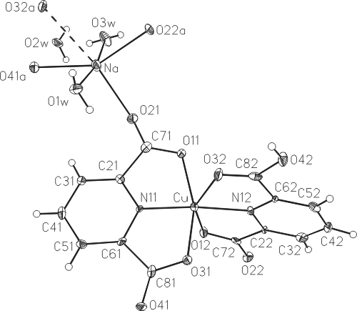

Fig. 1. An ORTEP drawing of the symmetry independent part of the crystal structure of {[Na(H₂O)₂][Cu(2,6-pydca)-(2,6-pydcaH)]⋅H₂O}_{n} with completed environment of the sodium atom.

Present work has been financially supported by the Grant Agency of the Slovak Republic (Grant No. 1/2452/05) and Technology Assistance Agency under the contract No. APVT-20-005504.

REFERENCES
1. Palicová M., Segľa P., Mikloš D., Kopcová M., Melník M., Dudová B., Hudecová D.,
Glowiak T.: Polyhedron, 19, 2689 (2000).
2. Mikloš D., Segľa P., Palicová M., Kopcová M., Melník M., Valko M., Glowiak T.,
Korabik M., Mrozinski J.: Polyhedron, 20, 1867 (2001).
3. Segľa P., Mikloš D., Olejníková P., Kaliňáková B., Hudecová D., Palicová M., Švorec J.,
Valko M., Melník M., Glowiak T.: Inorg. Chim. Acta, 357, 4172 (2004).
4. Koman M., Moncol J., Hudecova D., Dudova B., Melnik M., Korabik M., Mrozinski J.,
(2001) Pol. J. Chem., 75, 957
5. Mikloš D., Segľa P., Koman M., Jašková J., Glowiak T., Melník M.: DMS-RE,
Proceedings of the 14th Joint Seminar, Eds. K. Nitsch, M. Rodová, Lednice 2004, 39
6. Koman M., unpublished results.

